

**CEN3031 Spring 2021**

**Project Manager**

Lisa Touchton

**Scrum Master**

Adam Slavny

Sagan Sutherland

Nicole Telesz

**Animex**

A discussion board for the UF Anime Club. Functions as a mix of a forum and a chatroom.

**Main Features in MVP**

* Pick a specific topics from a “board”
* When a board is joined, a user can create or join a discussion
* Be able to discuss the topic using a chat feature

**Potential Features**

* The ability to create/search tags
* Account system to mitigate the risk of trolling
  + Moderator accounts who can manage discussion boards directly
* Create polls and/or quizzes as a discussion head

**Software**

The web application will be made using an application framework such as React. This will allow us to have a working front-end and back-end without setting up each individually and allow for local testing. Time permitting, we can make the website live using Amazon Elastic Beanstalk or other cloud hosting services.

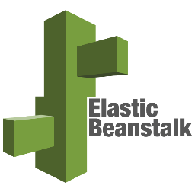

**Project Management Tool**

For project management, our team will use Trello to keep track of the items we need to complete before each sprint. Each card will have an assigned team member, date to complete and we will prioritize features needed for our MVP before adding something new.

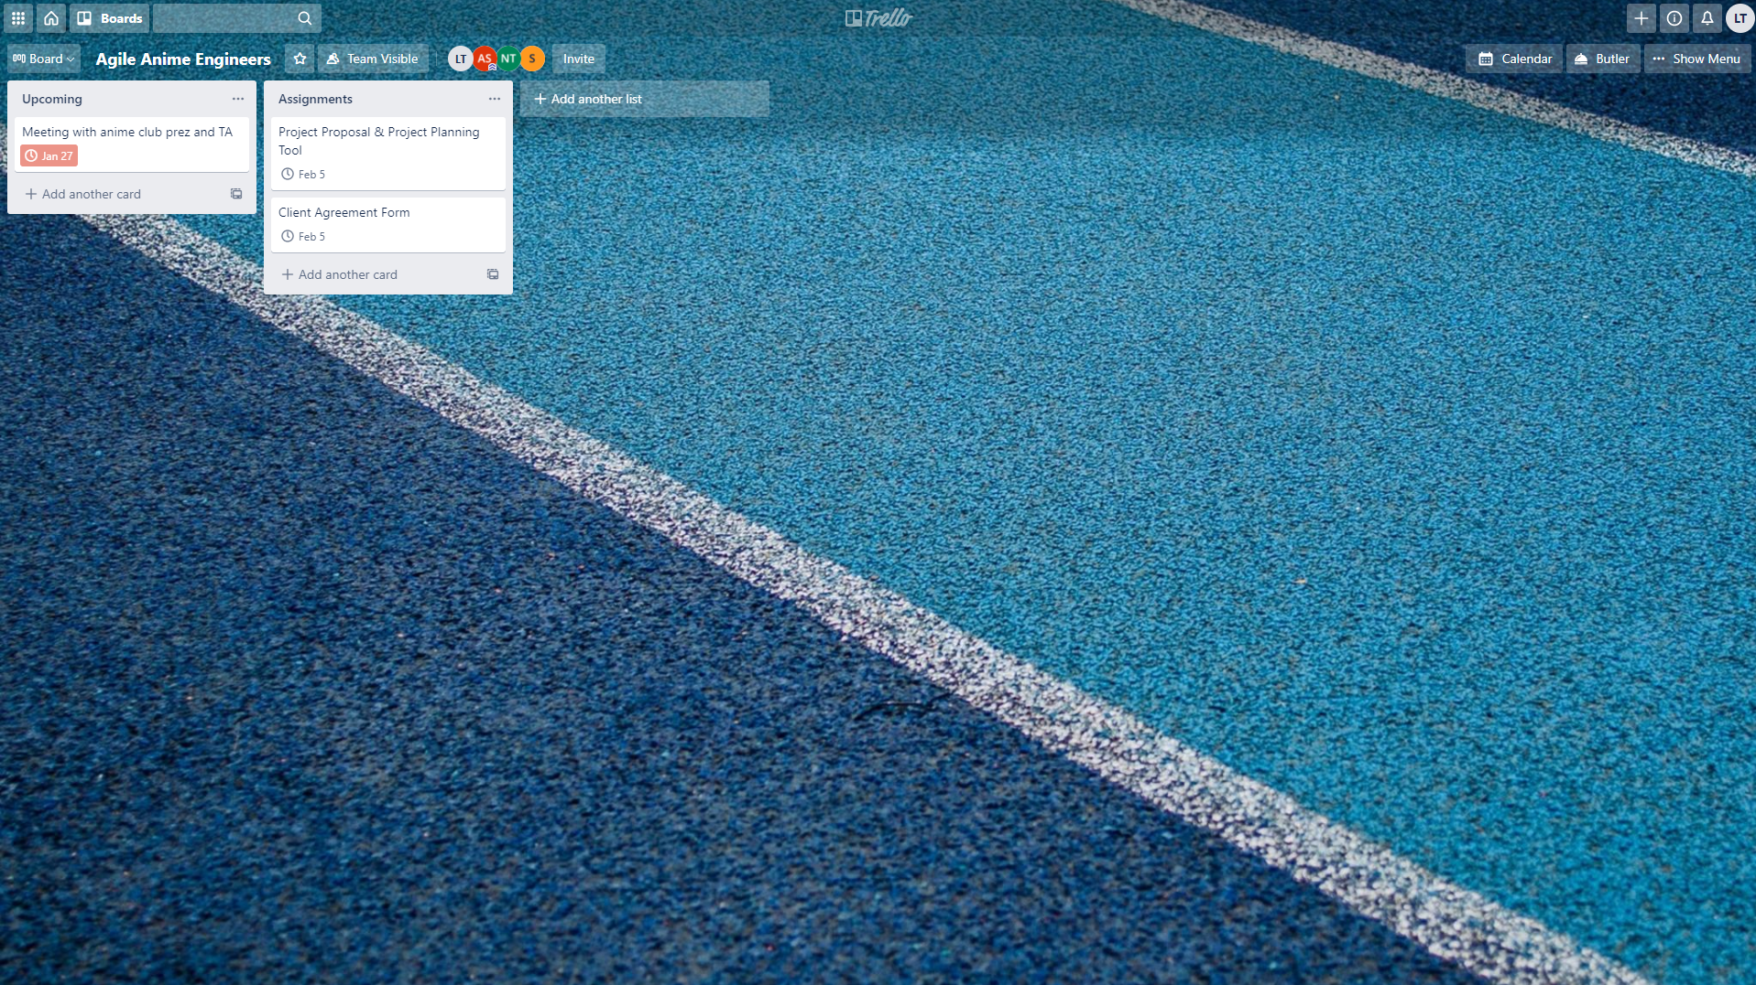

**Risk Management Plan**

Potential risks include: part of the dev team getting sick or otherwise not being able to work, part of the dev team not being able to finish work assigned to them in a timely fashion, etc. In the event that a risk becomes a reality, the whole team should be made aware of it as early as possible. The effect should be spread among the available team members evenly, so as to minimize the effect for each individual team member. Another form of risk management we will be using is version control to ensure we are not rewriting each others’ revisions.